Supplementary Table 1. Covariates for matched individuals with prediabetes or normal glycemic status
Covariates | Normal glycemic status  n = 373 | Prediabetes  n = 373 | Total  n= 746
Age (years), mean (SD) | 65.47 (10.82) | 65.48 (10.22) | 65.47 (10.51)
Male, n(%) | 290 (77.7%) | 295 (79.1%) | 585 (78.4%)
BMI (kg/m²), mean (SD) | 24.85 (3.37) | 24.87 (3.00) | 24.86 (3.19)
Hypertension, n(%) | 254 (68.1%) | 257 (68.9%) | 511 (68.5%)
LDL (mmol/L), mean (SD) | 2.38 (0.83) | 2.37 (0.87) | 2.37 (0.85)
Triglyceride (mmol/L), mean (SD) | 1.65 (0.94) | 1.66 (1.03) | 1.66 (0.98)
Statins use, n(%) | 158 (42.4%) | 152 (40.8%) | 310 (41.6%)
Acute heart failure, n(%) | 5 (1.3%) | 5 (1.3%) | 10 (1.3%)
Chronic heart failure, n(%) | 22 (5.9%) | 26 (7.0%) | 48 (6.4%)
Stroke, n(%) | 32 (8.6%) | 29 (7.8%) | 61 (8.2%)
Atrial fibrillation, n(%) | 16 (4.3%) | 14 (3.8%) | 30 (4.0%)

Supplementary Table 2. Covariates for matched individuals with diabetes or normal glycemic status
Covariates | Normal glycemic status  n = 452 | Diabetes  n = 452 | Total  n = 904
Age, mean (SD) | 66.19 (10.98) | 66.29 (10.94) | 66.24 (10.95)
Male, n(%) | 332 (73.5%) | 326 (72.1%) | 658 (72.8%)
BMI, mean (SD) | 25.07 (3.26) | 25.07 (3.33) | 25.07 (3.29)
Hypertension, n(%) | 364 (80.5%) | 355 (78.5%) | 719 (79.5%)
LDL, mean (SD) | 2.19 (0.78) | 2.20 (0.84) | 2.20 (0.81)
Triglyceride, mean (SD) | 1.77 (1.58) | 1.81 (1.25) | 1.79 (1.43)
Statins use, n(%) | 198 (43.8%) | 195 (43.1%) | 393 (43.5%)
Acute heart failure, n(%) | 10 (2.2%) | 8 (1.8%) | 18 (2.0%)
Chronic heart failure, n(%) | 32 (7.1%) | 38 (8.4%) | 70 (7.7%)
Stroke, n(%) | 41 (9.1%) | 38 (8.4%) | 79 (8.7%)
Atrial fibrillation, n(%) | 17 (3.8%) | 23 (5.1%) | 40 (4.4%)

Supplementary Table 3. Association between glycemic disorder and ACS among people with severe coronary stenosis*
 | odds ratio (95% CI) | p-value | β value | SE
Unadjusted Model
No DM | reference
Prediabetes | 0.78 (0.59 – 1.03) | 0.079 | -0.253 | 0.143
DM | 0.89 (0.67 – 1.19) | 0.434 | -0.114 | 0.145
Model 1ª
No DM | reference
Prediabetes | 0.77 (0.58 – 1.02) | 0.068 | -0.265 | 0.145
DM | 0.96 (0.72 – 1.28) | 0.773 | -0.042 | 0.148
Model 2^{b}
No DM | reference
Prediabetes | 0.77 (0.57 – 1.04) | 0.088 | -0.266 | 0.155
DM | 1.05 (0.77 – 1.44) | 0.760 | 0.049 | 0.162
ª Adjusted for age, sex, BMI and hypertension.
^{b} Adjusted for age, sex, BMI, hypertension, low-density lipoprotein, triglyceride level, statins use, chronic heart failure history, acute heart failure history, stroke history, and atrial fibrillation history.
*Coronary stenosis here is defined as Coronary Artery Disease Reporting and Data System (CAD-RADS). Participants with severe coronary artery stenosis was defined as more than 70% stenosis in more than one (including one) coronary arteries, which was equivalent to the CAD-RADS score ≥4A.

Supplementary Table 4. Association between prediabetes and ACS among people with coronary stenosis
 | odds ratio (95%CI) | p-value | β value | SE
Criteria 1ª
No DM | reference
Prediabetes (5.7-6.0) | 0.75 (0.52 - 1.09) | 0.133 | -0.284 | 0.189
Prediabetes (6.0-6.4) | 0.40 (0.25 - 0.66) | <0.001 | -0.907 | 0.248
Criteria 2^{b}
No DM | reference
Prediabetes | 0.97 (0.67 - 1.42) | 0.877 | -0.030 | 0.196
Criteria 3^{c}
No DM | reference
Prediabetes | 0.85 (0.50 - 1.46) | 0.564 | -0.156 | 0.271
ªCriteria 1: HbA1c:5.7-6.0% , HbA1c: 6.0-6.4%
^{b}Criteria 2: Fasting plasma glucose (FPG): 5.6-6.9 mmol/L
^{c}Criteria 3: 5.7<= HbA1c<6.4 and FPG: 5.6-6.9
Multivariable logistic model adjusted for age, sex, BMI, hypertension, low-density lipoprotein, triglyceride level, statins use, chronic heart failure history, acute heart failure history, stroke history, and atrial fibrillation history.

Supplementary Table 5. Association between HbA1c and fasting glucose level and ACS among people in non-diabetic individuals at admission
 | odds ratio (95% CI) | p-value | β value | SE
Unadjusted Model
HbA1c | 1.07 (0.88 – 1.29) | 0.440 | 0.071 | 0.093
Fasting plasma glucose | 1.14 (1.05 – 1.25) | 0.002 | 0.135 | 0.044
Model 1ª
HbA1c | 1.10 (0.91 – 1.32) | 0.324 | 0.094 | 0.095
Fasting plasma glucose | 1.16 (1.06 – 1.27) | 0.001 | 0.152 | 0.046
Model 2^{b}
HbA1c | 1.09 (0.90 – 1.32) | 0.380 | 0.095 | 0.099
Fasting plasma glucose | 1.15 (1.05 – 1.27) | 0.003 | 0.136 | 0.050
ª Adjusted for age, sex, BMI and hypertension.
^{b} Adjusted for age, sex, BMI, hypertension, low-density lipoprotein, triglyceride level, statins use, chronic heart failure history, acute heart failure history, stroke history, and atrial fibrillation history.

Supplementary Fig. 1. Covariate balance between matched and unmatched cohort in participants with prediabetes and normal glycemic status

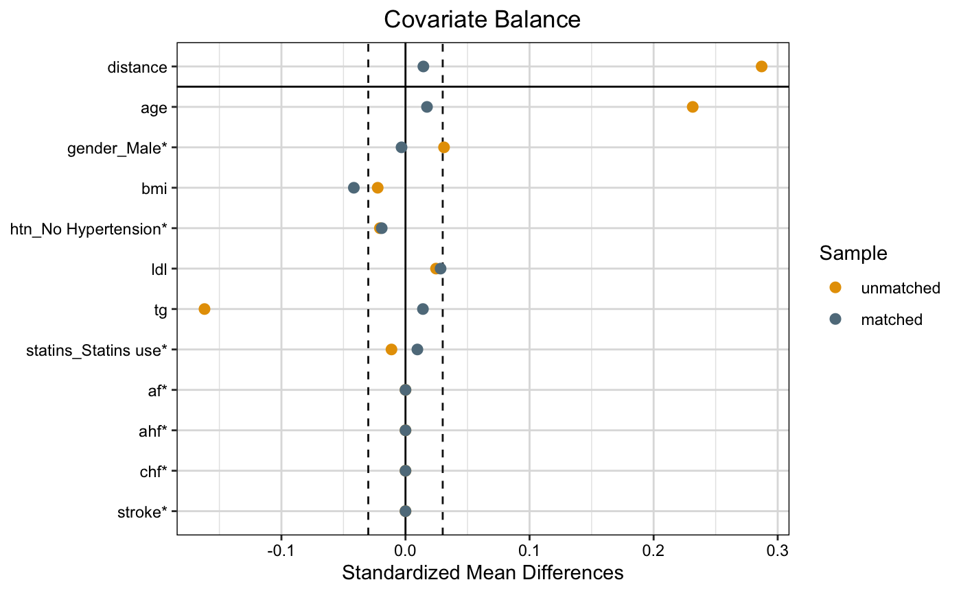
*, dichotomous variable.
TG, triglyceride; AF, atrial fibrillation; AHF, acute heart failure; CHF, chronic heart failure.

Supplementary Fig. 2. Propensity score distribution among participants with prediabetes and normal glycemic status

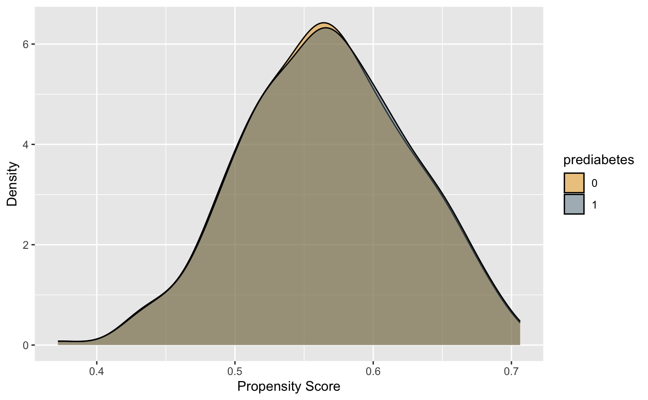

Supplementary Fig. 3. Covariate balance between matched and unmatched cohort among participants with diabetes and normal glycemic status
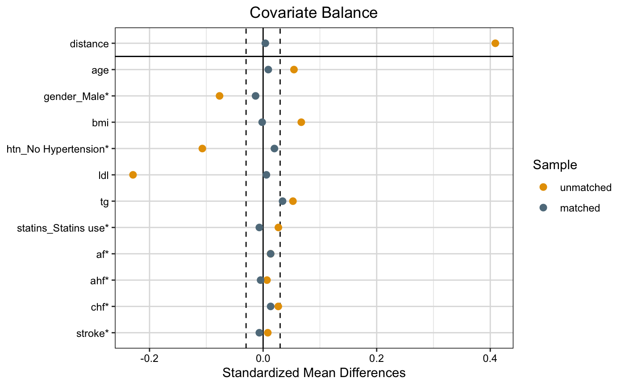
*, dichotomous variable.

Supplementary Fig. 4. Propensity score distribution among participants with diabetes and normal glycemic status
